**Lab 01 - Modulation**

# Part I: Scavenger Hunt

Find the hidden signal that is being broadcast within the range.

Instructions

1. Connect to one of the remote radios listed below using SDR#.
2. Scan through the signals, the signal uses a narrow bandwidth
3. Listen to the audio through your speakers, you’ll find a few different transmissions. If at first you think you’re getting trolled by the Russians, you’re close, but the trolling isn’t the secret message itself.
4. Take a screenshot of discovering the signal. What is the signal saying (audio)?

Deliverables

* What is the secret message?
  + The secret message is "Mary had a little lamb, its fleece was white as snow."
* Include a screenshot showing that you’ve found it in SDR#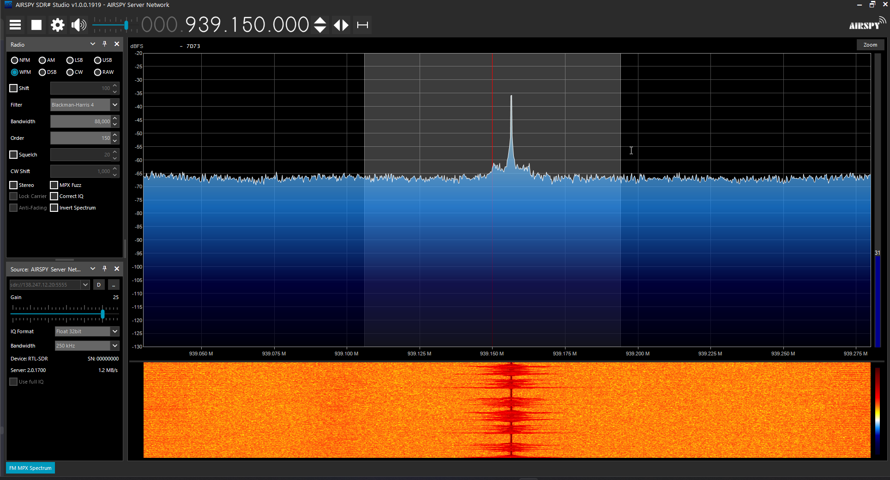

# Part II: Triangulation

|  |  |
| --- | --- |
|  | Received power  the strength of the signal as it arrives at the receiving antenna |
|  | Gain of receiving antenna  how effectively the receiving antenna captures the incoming signal |
|  | Gain of transmitting antenna.  how effectively the transmitting antenna sends the signal in a particular direction |
|  | Transmitted power.  the power with which the signal is initially transmitted from the transmitting antenna. |
|  | Distance between transmitting and receiving antennas  The propagation distance affects the signal strength.  units for wavelength and distance must be the same |
|  | Wavelength of the signal.  The wavelength is a factor in understanding how the signal behaves in space.  C= 3.0*10^8 m/s  λ = c / f, speed of light (c) and the frequency (f):  units for wavelength and distance must be the same |

Find distance formula

Find wavelength

Since all frequencies are 450kHz, we can solve for the wavelength before we start

* Base Station 1:
  + Location: 44.012320,-97.109509
  + Power Transmitted: 200 watts
  + Power Received: 17.3512367 watts
  + Transmitter Gain: 10
  + Receiver Gain: 25
  + Frequency: 450 kHz

Gt=1025

* + Location:

Gt=1

D=180.114

* Base Station 2:
  + Location: 44.013371,-97.289582
  + Power Transmitted: 200 watts
  + Power Received: 0.99757704 watts
  + Transmitter Gain: 10
  + Receiver Gain: 25
  + Frequency: 450 kHz

Gt=1025

Gt=1

D=751.174

* Base Station 3:
  + Location: 44.119244,-97.215958
  + Power Transmitted: 200 watts
  + Power Received: 0.9337055 watts
  + Transmitter Gain: 10
  + Receiver Gain: 25
  + Frequency: 450 kHz

Gt=1

D=776.442

((1)/(4π))×(√((G_*G_t*P_t*λ^2)/P_r ))

((1)/(4π))×(√((25*10*200*(((3.0)×(10^8))/((4.5)×(10^5)))^2)/(17.3512367)))

* 1. o Where is our transmitter at? Take a screenshot from a mapping tool showing that you’ve found the rough location.
  2. Our transmitter is located at 44.022840, -97.141945